3A - Measurement – Lesson 05
Units and Applications – Rate Conversion

Name: _________________
- Why do we need rate conversions?

- Make the following conversions.
Length
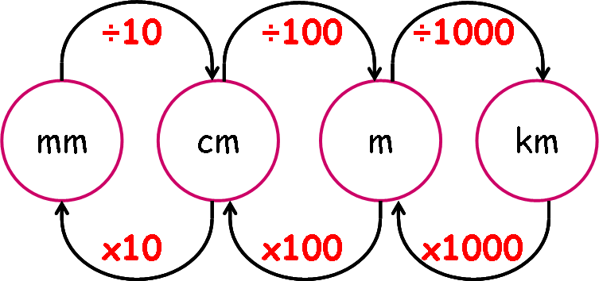

- 4.8 m to cm | - 3.7 km to cm | - 300 mm to m

Area
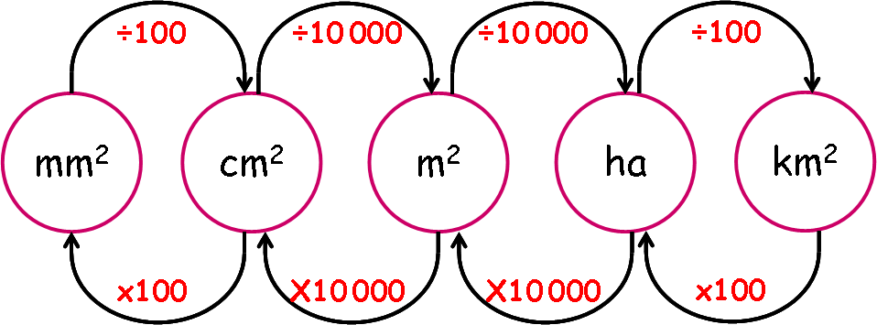

- 4500 mm² to cm² | - 3 ha to km² | - 3.7 m² to mm²

Volume
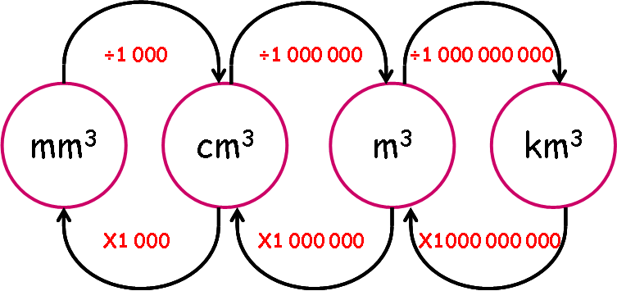

- 4500 mm³ to cm³ | - 55 000 000 cm³ to m³ | - 2.3 km³ to m³

Capacity
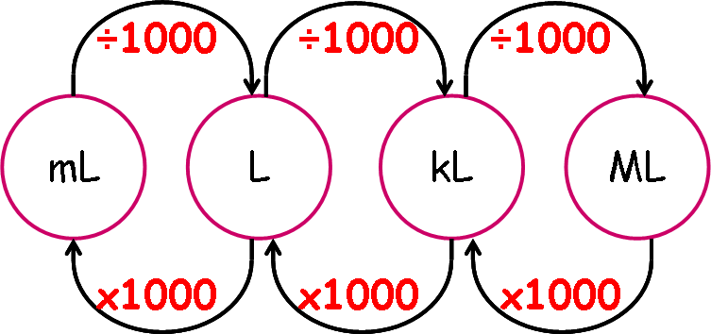

- 6500 mL to L | - 127 L to mL | - 1.7 ML to kL

Volume and Capacity
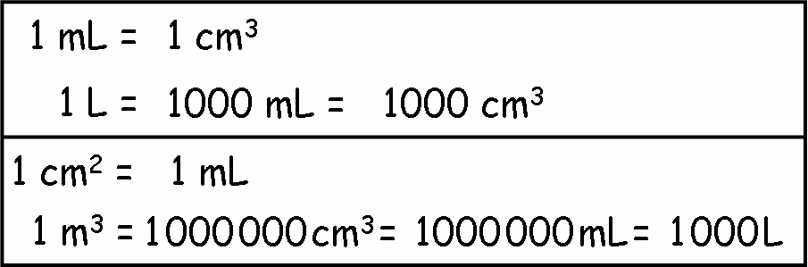

- 50 mL to cm³ | - 75 cm³ to mL | - 1250 L to m³

